Sta-ge | Augmented matrix | System of equations | Points, lines | Visualization
1 | R1/2 → R1 | 2x - 3y = -22  3x + 2y = -20  E1/2 → E1 | P = (-8,2)  L1 (red):  A1=(-5,4), B1=(-2, 6)  L2 (green):  A2=(-6 ,-1), B2=(-4,-4) | 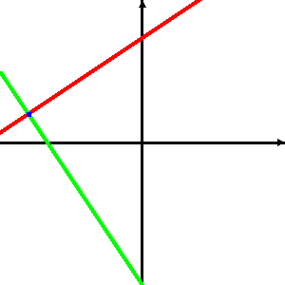
  2 | -3 | -22
  3 | 2 | -20
2 | R2 - 3*R1 → R2 | x - 3/2y = -11  3x + 2y = -20  E2 - 3*E1 → E2 | P = (-8,2)  L1 (red):  A1=(-5,4), B1=(-2, 6)  L2 (green):  A2=(-6 ,-1), B2=(-4,-4)
  1 | -3/2 | -11
  3 | 2 | -20
3 | R2/(13/2) → R2 | x - 3/2y = -11  13/2y = 13  E2/(13/2) → E2 | P = (-8,2)  L1 (red):  A1=(-5,4), B1=(-2, 6)  L2 (green):  A2=(-5 ,2), B2=(5,2) | 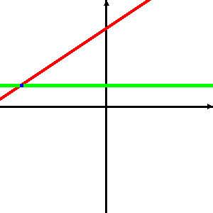
  1 | -3/2 | -11
  0 | 13/2 | 13
4 | R1 + (3/2)*R2 → R1 | x - 3/2y = -11  y = 2  E1 + (3/2)*E2 → E1 | P = (-8,2)  L1 (red):  A1=(-5,4), B1=(-2, 6)  L2 (green):  A2=(-5 ,2), B2=(5,2)
  1 | -3/2 | -11
  0 | 1 | 2
5 |  | x = -8  y = 2 | P = (-8,2)  L1 (red):  A1=(-8,5), B1=(-8, -5)  L2 (green):  A2=(-6 ,1), B2=(6,1) | 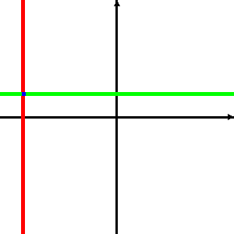
  1 | 0 | -8
  0 | 1 | 2

